**TEXAS INTERNATIONAL COLLEGE**

**TRIBHUVAN UNIVERSITY**

**FACULTY OF HUMANITIES AND SOCIAL SCIENCE**



**A**

**Project Report**

**On**

**DOCTOR APPOINTMENT**

**Submitted to**

**Department of Computer Application**

**Texas International College, Mitrapark, Kathmandu**

***In partial fulfillment of the requirements for the Bachelor in computer application***

***Submitted By***

Name: Niraj Paudel

TU Reg. No: 6-2-926-11-2020

Name: Rista Kafle

TU Reg. No: 6-2-926-20-2020

**TEXAS INTERNATIONAL COLLEGE**

**TRIBHUVAN UNIVERSITY**

**FACULTY OF HUMANITIES AND SOCIAL SCIENCE**



# SUPERVISOR’S RECOMMENDATION

We hereby recommend that this project is prepared by Niraj Paudel and Rista Kafle under supervision by Mr. Suman Thapaliya entitled “**DOCTOR’ APPOINTEMENT”** in partial fulfillment of the requirements for the degree of Bachelor of Computer Application be processed for the evaluation.

**SIGNATURE**

Mr. Suman Thapaliya

**SUPERVISOR**

**LETTER OF APPROVAL**

This is to certify that this project is prepared by **Niraj Paudel (6-2-926-11-2020**) and **Rista Kafle (6-2-926-20-2020)** entitled “**DOCTOR APPOINTMENT**” in partial fulfillment of the requirements for the degree of bachelor’s in computer application has been evaluated. In our opinion it is satisfactory in scope and quality as a project for the required degree.

|  |  |
| --- | --- |
| **.....................................................**  **SIGNATURE of Supervisor**  Suman Thapaliya | **...........................................................**  **SIGNATURE of HOD/Coordinator**  Department of Computer Application |
| **.....................................................**  **SIGNATURE of Internal Examiner Internal Examiner** | **...........................................................**  **SIGNATURE of External Examiner External Examiner** |

**ABSTRACT**

The current standard operating procedure in healthcare environment for patient registration and appointment scheduling are time consuming and somehow tiresome. Normally, we see patients coming to the hospital and filling out registration forms and waiting to be called or patient calls in for getting appointment and waits for the response for an agreed date. In some places appointment can be done online via web but still patient must walk in with the appointment card to be swiped by the front desk personnel before being sent to the concerned doctor. In view of these problems, many techniques like online patient registration and scheduling appointments, etc., have been suggested to improve the workflow and thereby smoothen the waiting time. However, these systems still possess some drawbacks like facilities towards prioritization, security level of patient and no reminder system present for these appointments. Considering these drawbacks, we here propose to develop an alternate Doctor appointment with a view to redefining the core of hospital waiting time towards appointment and also collection of reports. These are carried out in practice using appropriate NodeJS, JavaScript and MongoDB.

*Keyword: NodeJS, JavaScript, MongoDB.*

**ACKNOWLEDGMENT**

The success of this project would not have been possible without the kind support and assistance of our teachers and project group, and we are immensely blessed to have got this all through the duration of our project. We would like to extend our profound gratitude to every one of them.

We are very grateful to the department of computer applications. Texas Int’l College for providing us an opportunity to work on a major project as part of our second-year project. We are delighted to express our deep sense of gratitude and indebtedness to our learned supervisor **Mr. Suman Thapaliya**, Head of department at **Texas Int’l College** for his invaluable guidance, encouragement and even monitoring to spare time despite his busy schedule for project’s progress reviews.

I would like to express our special thanks of gratitude to our supervisor **Mr. Suman Thapaliya,** for giving us support throughout the course and thus made us capable of being worthy of recognition and extended every facility to us for making and completing this project smoothly.

Similarly, our thanks and appreciations also go to each one of our colleagues for their encouragement and support in developing the project.

# Table of Content

Table of Content vi

LIST OF ABBREVIATION: viii

List of Table ix

List of Figure x

CHAPTER 1: INTRODUCTION 11

1.1 Introduction 11

1.2 Problem Statement 11

1.3 Objectives 12

1.4 Scope and Limitation 12

1.5 Report Organization 13

CHAPTER 2: BACKGROUND STUDY AND REVIEW 15

2.1 Background Study 15

2.2 Literature Review 15

CHAPTER 3: SYSTEM ANALYSIS AND DESIGN 17

3.1 System Analysis 17

3.1.1 Requirement Analysis 17

3.2.1 Functional Requirements 17

3.2.2 Non-functional requirement 18

3.1.2 Feasibility Analysis 19

3.1.2.1 Technical 19

3.1.2.2 Operational 19

3.1.2.3 Economic 19

3.1.2.4 Schedule 20

3.1.3 Data Modelling(ER-Diagram) 22

3.1.4 Process Modelling 23

3.2 System Design 25

3.2.1 Architectural Design 25

3.2.2 Database Schema Design 25

3.2.3 Interface Design 27

CHAPTER 4: IMPLEMENTAION AND TESTING 28

4.1 Implementation 28

4.1.1 Tools Used (CASE tools, Programming languages, Database platforms) 28

4.1.2 Implementation Details of Modules (Description of procedures/functions) 28

4.2 Testing 29

4.2.1 Test Cases for Unit Testing 30

4.2.2 Test Cases for System Testing 30

CHAPTER 5: CONCLUSION AND FUTURE RECOMMENDATION 35

5.1 Lesson Learnt / Outcome 35

5.2 Conclusion 36

5.3 Future Recommendations 37

6. Reference 38

7. Appendices 38

7.1. Screen Shots 38

7.2. Source Codes 42

# LIST OF ABBREVIATION:

CSS : Cascading Style Sheet

HTML : Hypertext Markup Language

JS : Java Script

DFD : Data flow Diagram

ER : Entity Relationship

MongoDB : Database

Node JS : Backend

# List of Table

Table 4. 1: Admin Login Test 31

Table 4. 2: User Registration With Email 32

Table 4. 3: User Login with Email 33

Table 4. 4: System Testing 34

# List of Figure

Figure 3. 1: Use Case Diagram 18

Figure 3. 2: ER Diagram 22

Figure 3. 3: Context Diagram 23

Figure 3. 4: Level 1 DFD for User 23

Figure 3. 5: level 2 DFD for User 24

Figure 3. 6: Admin Side DFD 24

Figure 3. 7: Architectural Design 25

Figure 3. 8: Database Schema Diagram 26

Figure 4. 1: V-Model 29

Figure 7. 1: Home Page 38

Figure 7. 2: Sign Up 39

Figure 7. 3: Login page 39

Figure 7. 4: Food Listing 40

Figure 7. 5: Cart 40

Figure 7. 6: My Orders 41

Figure 7. 7: Admin Dashboard 41

# CHAPTER 1: INTRODUCTION

## Introduction

Doctor appointment is an arrangement to meet the doctor and patient at a particular time in the clinic or a hospital. It’s an innovative web-based platform designed to simplify the process of scheduling and managing medical appointments for patients, doctors, and administrators. This system aims to bridge the gap between healthcare providers and patients, ensuring timely access to medical consultations and facilitating the exchange of crucial medical information.

Doctor appointment is an arrangement to meet the doctor and patient at a particular time in the clinic or a hospital. It’s an innovative web-based platform designed to simplify the process of scheduling and managing medical appointments for patients, doctors, and administrators. This system aims to bridge the gap between healthcare providers and patients, ensuring timely access to medical consultations and facilitating the exchange of crucial medical information.

## Problem Statement

* Traditional appointment scheduling in healthcare settings often leads to inefficiencies, long waiting times, and missed opportunities for both patients and doctors. Patients must call the doctor's office, wait on hold, and then schedule an appointment that is often several weeks away. In some cases, patients may even have to physically go to the doctor's office to schedule an appointment.
* Traditional appointment scheduling in healthcare settings often leads to inefficiencies, long waiting times, and missed opportunities for both patients and doctors. Patients must call the doctor's office, wait on hold, and then schedule an appointment that is often several weeks away. In some cases, patients may even have to physically go to the doctor's office to schedule an appointment

## Objectives

The system aims to help patients to make appointments online through the internet and track their records through it. With the increase in the number of patients visiting, it has become difficult to manage the appointment system manually. For the receptionist it makes it easy to set the date and time for the treatment of the patient to the relevant doctor.

* To help doctors and other healthcare providers manage their schedules efficiently and reduce scheduling conflicts or overbooking.
* To Ensure the privacy and security of patient information.
* To Allow patients to reschedule or cancel appointments as needed.

## Scope and Limitation

The scope of this project in coming days will be more popular than imagine because this project will help customers.

* The system will allow patients to register, log in, and book appointments with available doctors.
* Patients can view their past and upcoming appointments and access medical reports.
* Doctors can log in, view their schedule, access patient information, and upload medical reports.
* The admin can manage doctor schedules, confirm patient appointments, and oversee the system's functioning.
* The system will be accessible from desktop and mobile devices for user convenience.

Some of the Limitation are:

* The system will not handle online payment for appointments or medical services.
* Communication between patients and doctors will primarily occur during in-person consultations.
* The system will not support video or telemedicine appointments.
* The system may not integrate with electronic health record (EHR) systems of healthcare institutions.

## Report Organization

Chapter 1: Introduction: In this chapter, you set the stage for your project by introducing the readers to Doctor’s appointment online appointment platform. You explain the purpose of the project, its significance, and its aims. You highlight the problems faced by the traditional appointment system, which this project intends to address. This chapter serves as an overview of what readers can expect from the report and why the project is important in the context of the health industry.

Chapter 2: Background Study and Review: In this chapter, you delve deeper into the background of the project. You conduct a study of existing online appointment systems, particularly focusing on their strengths and weaknesses. This involves researching and reviewing related platforms and technologies. You also perform a literature review, summarizing existing research, studies, and literature related to online platforms, online appointments, user experience, and technology. This chapter lays the foundation for understanding the project's context and the insights that informed its development.

Chapter 3: System Analysis and Design: Here, you get into the technical details of your project. You discuss the process of analyzing the existing doctor's online appointment processes, gathering requirements from stakeholders, and evaluating the feasibility of the project. This chapter includes the identification of functional and non-functional requirements, use cases, and user stories. You also outline the architecture and design considerations for Doctor's appointments. This chapter provides a comprehensive understanding of how you analyzed and planned the development of the platform.

Chapter 4: Implementation and Testing: This chapter focuses on the execution phase of your project. You detail how you implemented the Doctor appointment platform based on the analysis and design from the previous chapters. This includes software development, database creation, and integration of various functionalities. You also discuss the testing process to ensure the platform's functionality, security, and performance. This chapter provides insights into how your plans were translated into a functional system.

Chapter 5: Conclusion and Future Recommendations Here, you wrap up your project. You summarize the outcomes and impacts of Doctor appointment, emphasizing how it addresses the challenges identified in the introduction. You reflect on lessons learned during the project's development and the significance of your findings. Additionally, you present future recommendations to enhance Doctor appointment further. These recommendations are informed by the project's outcomes and aim to guide potential improvements and developments moving forward.

Appendices: The appendices section typically includes supplementary information that supports your main content. This might include detailed technical documentation, code snippets, user manuals, or any additional data that you reference in your report but want to keep separate from the main text.

References: The reference section lists all the sources you've cited throughout your report. This provides credibility in your work and allows readers to refer to the sources for further reading.

# CHAPTER 2: BACKGROUND STUDY AND REVIEW

## Background Study

Online booking appointments in healthcare is a growing trend that offers numerous benefits to patients and healthcare providers alike. With the increasing use of technology in healthcare, many practices and medical facilities have implemented online booking systems to allow patients to schedule appointments quickly and easily. One of the main advantages of online booking appointments in healthcare is convenience. Patients can book appointments from anywhere at any time, without the need for phone calls or in-person visits. This can be particularly beneficial for patients with busy schedules, mobility issues, or those who live far away from the medical facility.

Doctor appointment background study underscores the need for a more efficient and customer-centric approach to food appointment. By understanding the current limitations and opportunities in the industry, the platform offers a less time-consuming appointment and accurate time experience. Doctor appointment focus on easier and user-friendly appointment system, positioning it as a potential game-changer in the market.

## Literature Review

Doctor appointment delves into existing research and studies relevant to the health sector, online platforms, user experience, and the integration of less time-consuming appointment and real-time tracking in appointment. Research in the health sector indicates a rising demand for convenient online platforms driven by changing patients and doctor lifestyles. Traditional manual systems face challenges like delayed of appointment, appointment confirmation errors, and tracking of reports.

The implementation of tracking appointment time and view of reports has emerged as a potential solution to these challenges. Studies highlight how appointing at desired time of patients are fullfilled, reducing errors on patients info and missing reports. Moreover, the literature underscores the significance of user experience, emphasizing user-friendly interfaces for enhancing customer satisfaction. Insights gained from the literature review will inform the development of Doctor appointment, enabling the platform to offer an efficient, customer-centric, and technologically advanced online appointment booking for health sector.

Currently speaking there are various online doctor appointment system, who are working and competing together in the local as well in global market, some of these sites are:

1. **Merodoctor:**

**https://merodoctor.com/**

It is a telemedicine platform that allows patients to consult with doctors online. It provides access to licensed doctors and specialists for a range of medical issues. Patients can schedule appointments and access consultations through the Merodoctor website. Patients can search for and select doctors based on criteria such as specialization, location, availability, and ratings.

1. **Doctor on Demand:**

**https://doctorondemand.com/**

Doctor on Demand is a telemedicine platform that provides virtual medical consultations with licensed doctors, psychologists, and psychiatrists through video appointments. The platform accepts many major insurance plans and offers affordable out-of-pocket pricing for those without insurance coverage. It also provides virtual consultations with licensed psychologists and psychiatrists for mental health concerns.

# CHAPTER 3: SYSTEM ANALYSIS AND DESIGN

## System Analysis

The system analysis phase of the Doctor appointment project involves a comprehensive examination of the existing food delivery processes and the requirements for developing the online platform. This analysis aims to identify the key functionalities, features, and components necessary for the successful implementation of Doctor appointment.

This system will be completely web based and will be developed using PHP. We will have one home page where multiple options allow the user to choose different food items with the actual price. There will be a system administrator who will have the right to add and manage user accounts, a manager who will be managing product and orders.

### Requirement Analysis

This system needs to fulfil following functional and non-functional requirements.

### A diagram of a company Description automatically generatedFunctional Requirements

Figure 3. : Use Case Diagram

### Non-functional requirement

**Software requirements**

Operating system: Windows 10

Server: Apache 2.4.4

Front-end: EJS 3.1.9 (Framework: Bootstrap and CSS)

Back-end: NodeJS v20.8.0

We have used XAMPP which is a free and Open-Source Cross-Platform Web Server Solution Stack. It comes with Apache Web Server, MySQL Database and PHP*.*

**Hardware requirements (Minimum requirement & Recommended requirement)**

Processor: Intel dual core or above Processor Speed: 1.0GHZ or above RAM: 1 GB RAM or above

Hard Disk: 20 GB hard disk or above

### Feasibility Analysis

The feasibility analysis evaluates the practicality and viability of the Doctor appointment project, considering various aspects such as technical, operational, economic, legal, and scheduling factors. The analysis serves as a critical step in determining whether the project is worth pursuing and identifying potential challenges that need to be addressed.

### Technical

The Doctor appointment platform requires technical infrastructure for its development, such as a reliable server, database, and programming languages such as HTML, CSS, JavaScript, PHP, and SQL. The platform must also be optimized for various devices such as mobile, tablet, and desktop. These technical requirements are feasible to fulfill, and the required resources are readily available in the market.

### Operational

The Doctor appointment platform requires operational procedures for its development and deployment, such as user and restaurant registration, menu management, order management, delivery management, and customer feedback management. These procedures are feasible to develop and deploy, and a team of skilled individuals can manage them efficiently.

### Economic

The cost for H/W and S/W is feasible, as it requires investment at the start of the system of computer, printer etc. But the Store for which we are developing this project doesn’t possess any system. So, at the start they need to invest for this system working. The current manual system they require regular investment also require more storage space inform of cupboards. So, the software system which we are developing is feasible in economic aspects. Time-based study: - This is analysis of the time for required to achieve a return on investment (ROI) and benefits comes from the product system. The future value of a project is also depending upon it quality and factor. Cost-based study:

It is most important to identity cost and benefit factors and ROI which can be categorized as follows:

* + - * + Development costs
        + Operating costs
        + Cost of hardware
        + Cost of Operating system software
        + Cost of Application software
        + Cost of Documentation preparation

### Schedule

Schedule time evaluation is the most important consideration in the development of project. The time schedule required for the development of this project is very important. The proposed system would be designed as per the time calculated. Likelihood that timeframes can be met and that this adequate to meet organization's needs.

Table 3. : Gantt Chart

|  |  |  |  |  |  |  |
| --- | --- | --- | --- | --- | --- | --- |
| **Task/Month** | **1st -2nd**  **Week** | **3rd - 4th**  **week** | **5th – 6th**  **week** | **7th – 10th**  **week** | **11th**  **week** | **12th**  **week** |
| **Requirement**  **Gathering** |  |  |  |  |  |  |
| **Planning** |  |  |  |  |  |  |
| **Design** |  |  |  |  |  |  |
| **Development** |  |  |  |  |  |  |
| **Testing** |  |  |  |  |  |  |
| **Deployment** |  |  |  |  |  |  |
| **Documentation** |  |  |  |  |  |  |

### Data Modelling (ER-Diagram)

Entity Relationship Diagram of Doctor appointment.

Figure 3. : ER Diagram

### A diagram of a software application Description automatically generatedProcess Modelling

Figure 3. : Context Diagram

Figure 3. : Level 1 DFD for Admin

USER DFD FOR DOCTOR APPOINTMENT

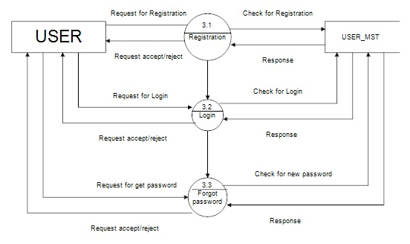Figure 3. : level 2 DFD for User

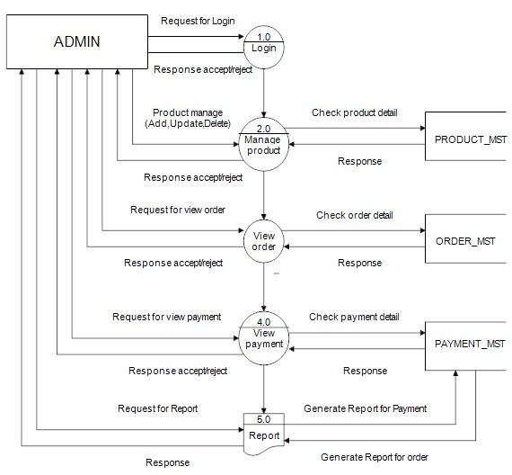

DOCTOR DFD FOR DOCTOR APPOINTMENT

Figure 3. : Admin Side DFD

## System Design

### Architectural Design

### 

Figure 3. : Architectural Design

### Database Schema Design

Database is a large collection of inter-related data stored with minimum redundancy and used especially for rapid search and retrieval. The general objective is to make information secure, flexible for the user and to reduce data duplication.

#### Database Schema

Figure 3. : Database Schema Diagram

### Interface Design

The interface design phase of the Doctor appointment project focuses on creating an intuitive and user-friendly visual representation of the platform's functionalities. This phase is crucial as it directly impacts user experience and engagement. Here's how the interface design process can be structured:

* **User-Centered Design Approach:**
  + Prioritize the needs and preferences of users, including patients, doctors, and hospitals.
  + Gather user feedback through surveys, focus groups, or user interviews to understand their expectations and pain points.
  + Develop user personas that represent different types of users to guide design decisions.
* **Wire framing:**
  + Create low-fidelity wireframes that outline the basic layout, structure, and placement of elements on each screen.
  + Wireframes help visualize the user journey, ensuring that essential features are included, and the interface is intuitive.
* **Prototyping:**
  + Develop interactive prototypes using tools like Figma.
  + Prototypes allow users to interact with the platform's interface, giving you insights into usability and identifying areas for improvement.
* **Visual Design:**
  + Define the color scheme, typography, and visual elements that align with Doctor appointment 's brand identity.
  + Create high-fidelity mockups that showcase the final look and feel of the user interface.

# CHAPTER 4: IMPLEMENTAION AND TESTING

## Implementation

### Tools Used (CASE tools, Programming languages, Database platforms)

Before diving into the actual code, it's essential to create artifacts like Entity-Relationship (ER) diagrams, Flowcharts, and Data Flow Diagrams (DFD) using tools like Word and draw.io online editor. These artifacts provide a visual representation of the system, aiding in better understanding and planning.

The chosen server-side scripting language for the implementation is NodeJS serves as an intermediary between the frontend and backend, handling user inputs and performing manipulations, validations, and data processing. For the frontend, HTML, CSS, and JavaScript framework are employed to create a user-friendly and responsive interface. On the backend, MongoDB Server is utilized to store, update, and retrieve data, allowing NodeJS to interact with the database and present information to the user's browser.

In summary, the implementation phase involves using PHP to process user inputs, perform data manipulations, and communicate with the backend MySQL Server. The frontend is developed using HTML, CSS, and Bootstrap, providing a well-designed and interactive interface to the users. This well-structured approach ensures the successful development of the software system..

### Implementation Details of Modules (Description of procedures/functions)

Following are all the modules designed for Doctor appointment .

#### Admin Module

This module is only authorized for admin. Only admin can access the functionality created over there. Admin need to login to access to this panel after authenticated they redirect to the admin page. Admin can insert the food menu and category details, add it, delete it if necessary. Moreover, Admin can see the list of order details and can delete after deliver to the Customer.

#### Doctor Module

In this module user can see all the list of the products available with number of rated in each product. Anyone can visit this page or interface. In this page image of food, category of food, name of food and purchase options are shown to the user. Moreover, user can click for the purchase option and then they will be redirect to the register/login page where they can fill their credentials to register or login.

#### Patient Module

In this module only authorized user after login can choose the food and click on add to cart and then checkout. user can also do logout.

#### Report Module

In this module payment is done via cash only but only when the user add item to the cart and details such as phone, email, name, address is provided.

## Testing

Among disparate available models and methods for testing we’ve elected for the V-model software testing in which we will test our software from the core to the most outer module or layer of the software.

Figure 4. : V-Model

### Test Cases for Unit Testing

First stage of the V model is the Unit Testing, where each and every unit/ component of the model used in several functions and tasks are first tested individually to find defects or incompatibilities in a faster way. This lets us observe errors or bugs and helps us devise solutions against them at a low level as if, we can treat the errors and issues examining the root of the problem which eventually will help us treat future problems too.

The modules in our project are the User Module and the Administration Module, each which have several more components with functions together working as a whole. E.g., the user’s side’s operations such as creating an account for the booking purpose and getting logged in to the website. so, we need to test all these functions respectively with the worst-case scenarios for them. The Administrator module includes the same The next unit which incurred the process to store the records in our created database and then using it and viewing it for the administration purpose. All these units are tested one by one in this UNIT TESTING.

### Test Cases for System Testing

The objective is to make the user feel great about the project and then make him understand the quality of the software. The lesser the complexity of the project, the more the user will prefer to use the software on his desire. Our software satisfies that property.

In this way, we have carried out testing for our application in a solicitous way.

Table 4. : Admin Login Test

|  |  |  |  |  |  |  |
| --- | --- | --- | --- | --- | --- | --- |
| **Test**  **Case ID** | **Test Scenario** | **Test Steps** | **Test Date** | **Expected Results** | **Actual Results** | **Pass/ Fail** |
| TC1 | Check Admin Login with valid data | 1. Go to site http://localhost/thali/index.php 2. Enter Email 3. Enter Password 4. Click Login | Email=[admin@](mailto:admin@gmail.com) [gmail.com](mailto:admin@gmail.com) Password=admi n | Admin should be login into application | As Expected | Pass |
| TC2 | Check admin Login with invalid Data | 1. Go to site 2. Enter Email 3. Enter Password 4. Click Login | Email=[admin1](mailto:admin1@gmail.com) [@gmail.com](mailto:admin1@gmail.com) Password=admi n12346 | Admin should not be login into application | As Expected | Pass |

Table 4. : User Registration With Email

|  |  |  |  |  |  |  |
| --- | --- | --- | --- | --- | --- | --- |
| **Test Case ID** | **Test Scenario** | **Test Steps** | **Test Date** | **Expected Results** | **Actual Results** | **Pass/ Fail** |
| TC3 | Check Customer Register with valid email | 1. Go to site <http://localhost>   /thali/index.php   1. First Name 2. Last Name 3. Enter Address 4. Enter pincode 5. Enter Email 6. Enter Password 7. Click Sign up | Name= User  Email=c1@Doctor appointment  Password=pass1 | User should  get register  if email  is  valid. | As Expected | Pass |
| TC4 | Check Customer Register with repeated email | 1. First Name 2. Last Name 3. Enter Address 4. Enter pincode 5. Enter Email 6. Enter Password 7. Click Sign up | Name=Random User  Email=random.com  Password=12345 | Email is not valid  message  should  show. | As  Expected | Pass |

|  |  |  |  |  |  |  |
| --- | --- | --- | --- | --- | --- | --- |
| **Test Case ID** | **Test Scenario** | **Test Steps** | **Test Date** | **Expected Results** | **Actual Results** | **Pass/ Fail** |
| TC5 | Check Customer Login with valid Data | 1. Go to site http://localhost:3000/ 2. Enter Email 3. Enter Password 4. Click Login | Email= c1@Doctor appointment  Password=pass1 | Customer should be login into application | As Expected | Pass |
| TC6 | Check Customer Login with not registered Data | 1. Go to site 2. Enter Email 3. Enter Password 4. Click Login | Email= random.com Password=12345 | Customer should not be login into application | As Expected | Pass |

Table 4. : User Login with Email

Table 4. 4: System Testing

|  |  |  |  |  |  |  |
| --- | --- | --- | --- | --- | --- | --- |
| **Test Case ID** | **Test Scenario** | **Test Steps** | **Test Date** | **Expected Results** | **Actual Results** | **Pass/ Fail** |
| TC7 | Adding Item to Cart | 1. Go to site http://localhost/thali/food.php 2. Browse Desire Product 3. Click Add to Cart | 7/19/22023 | Product should be added on Cart | As Expected | Pass |
| TC8 | Check to purchase product | 1. Go to site 2. login 3. Click on Cart 4. Click on COD 5. Order Placed | 7/19/22023 | Ordered should be placed | As Expected | Pass |
| TC9 | Check Previous Order | 1. Go to site 2. login 3. Click on Orders 4. Check Previous Order | 7/19/22023 | Previous Orders Displayed | As Expected | Pass |
| TC10 | To Check LogOut From System | 1. Go to site 2. Login 3. Click on Logout | 7/19/22023 | User should be Logged out | As Expected | Pass |

# CHAPTER 5: CONCLUSION AND FUTURE RECOMMENDATION

## Lesson Learnt / Outcome

Throughout the development of Doctor appointment , several valuable lessons were learned, leading to significant outcomes that shaped the project's success and impact:

1. User-Centric Approach: The importance of adopting a customer-centric approach was emphasized during the project. Understanding and addressing the needs, preferences, and pain points of users played a pivotal role in designing a platform that resonated with users and enhanced their overall experience.
2. Continuous Improvement: Embracing a culture of continuous improvement proved crucial. Feedback from users is actively sought and incorporated into the platform's development. This iterative process ensured that Doctor appointment evolved to meet the changing demands of the online application.
3. Technology Advancements: Leveraging automation and real-time tracking technologies proved to be a game-changer. These innovations streamlined the appointment process, reduced errors, and offered users transparency and control over their reports, leading to increased satisfaction.
4. Adaptability and Flexibility: Flexibility was key in navigating unforeseen challenges and changes. The ability to adapt to evolving circumstances and refine strategies allowed Doctor appointment to remain competitive and responsive to market dynamics.

Outcome:

As a result of the lessons learned, Doctor appointment achieved notable outcomes and impacts in the food delivery industry:

1. Enhanced Users Experience: Doctor appointment became synonymous with a seamless, user-friendly, and convenient appointment and online experience. The real-time tracking feature empowered users with control and confidence, resulting in increased users loyalty.
2. Increased Efficiency: The platform's automation significantly improved the order processing time, reducing manual efforts and minimizing errors. This led to faster order confirmations and a smoother order fulfillment process.
3. Improved Hospital Performance: Partnering with Doctor appointment proved advantageous for hospitals, leading to increased visibility, streamlined order management, and improved efficiency in fulfilling users request.
4. Positive Industry Disruption: Doctor appointment's success and innovative practices disrupted traditional appointment booking services, inspiring others in the industry to adopt online appointment and real-time tracking, ultimately benefiting the entire appointment ecosystem.

## Conclusion

The development of Doctor appointment has been a journey marked by innovation, perseverance, and a commitment to take appointment excellence in the health industry. Through a users-centric approach and leveraging cutting-edge technologies, Doctor appointment has emerged as a transformative platform, revolutionizing the way getting appointment booked.

By conducting a thorough system analysis and understanding the challenges faced by traditional manual systems, Doctor appointment was designed to address these pain points. The integration of automation and real-time tracking has led to enhanced efficiency, reduced errors, and improved overall users satisfaction. The platform's intuitive user interface and continuous improvement initiatives have garnered positive feedback from users and partners, solidifying Doctor appointment as a market leader.

Through partnerships with hospital , Doctor appointment has created a dynamic ecosystem that benefits all stakeholders. Hospitals enjoy increased visibility and streamlined order management, while users experience optimized routines and improved efficiency.

In conclusion, Doctor appointment stands as a testament to the power of technology and customer-centricity in revolutionizing an industry. The journey of Doctor appointment has been one of growth, learning, and positive disruption, leaving a lasting mark on the food delivery landscape. As we move forward, Doctor appointment remains committed to its mission of providing a seamless and efficient food delivery experience, enriching the lives of customers, restaurants, and delivery persons alike.

## Future Recommendations

While Doctor appointment has achieved remarkable success and made a significant impact on the food delivery industry, there are several future recommendations to further enhance the platform's capabilities and maintain its position as a market leader:

1. Live Tracking of Delivery Boy: Implement real-time tracking of the delivery person's location on the customer's app or website. This feature will allow customers to track the delivery person's exact location and estimated time of arrival, enhancing transparency and reducing anxiety about the order's status. Live tracking will provide customers with a sense of control and assurance during the delivery process.
2. Restaurant Updates about the Order: Introduce a notification system that keeps customers informed about the order's progress at the restaurant. Customers should receive real-time updates when the restaurant starts preparing the order, when it is ready for pickup, and when it is handed over to the delivery person. This proactive communication will keep customers engaged and informed, leading to a seamless and delightful ordering experience.
3. Interactive Chat Support: Implement an interactive chat support feature to facilitate instant communication between customers, restaurants, and delivery persons. Customers can inquire about order details, request modifications, and resolve any issues through the chat support. This feature will enhance customer satisfaction by providing swift and efficient support.

By incorporating these enhancements, Doctor appointment can create a dynamic and innovative food delivery platform that not only meets current expectations but also anticipates and exceeds the future needs of its users. Embracing technology-driven features will solidify Doctor appointment as a market leader, providing a cutting-edge and unparalleled food delivery experience for customers, restaurants, and delivery persons alike.

# 6.Reference

* + S. Dwivedi, “Food Delivery System,” Merokinmel.com. [Online]. Available: https://www.merokinmel.com/. [Accessed: 05-Apr-2023].
  + Tutorials Point, “SDLC - Waterfall Model,” Tutorials Point. [Online]. Available: https://www.tutorialspoint.com/sdlc/sdlc_waterfall_model.htm#. [Accessed: 05-Apr-2023].
  + Tutorials Point, “SDLC - Agile Model,” Tutorials Point, 2001. [Online]. Available: https://www.tutorialspoint.com/sdlc/sdlc_agile_model.htm. [Accessed: 06-Apr-2023].

# Appendices

# C:\Users\siddh\AppData\Local\Microsoft\Windows\INetCache\Content.Word\Screenshot 2023-08-03 at 16-23-12 Home.pngScreen Shots

Figure 7. : Home Page

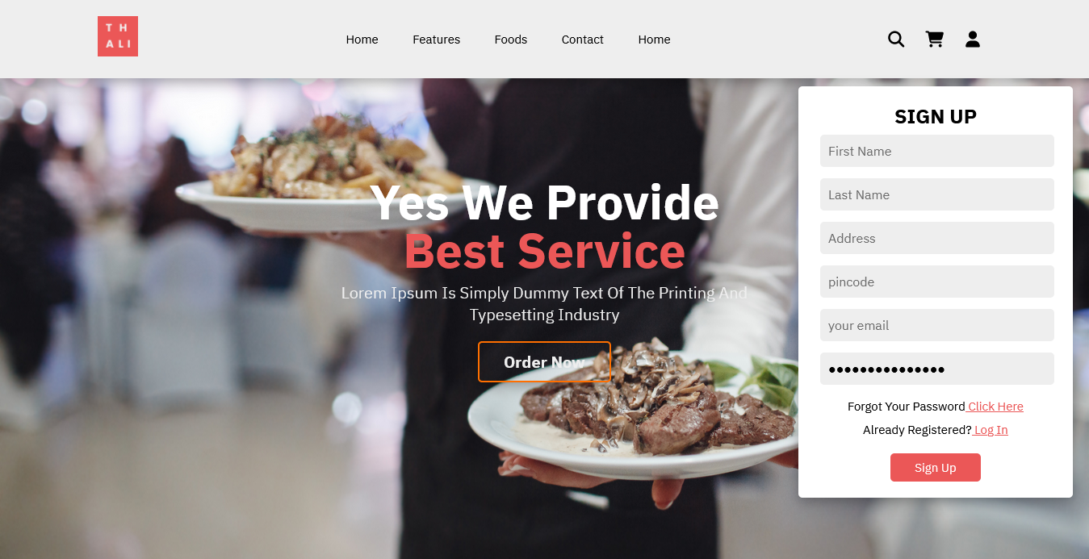Figure 7. : Sign Up

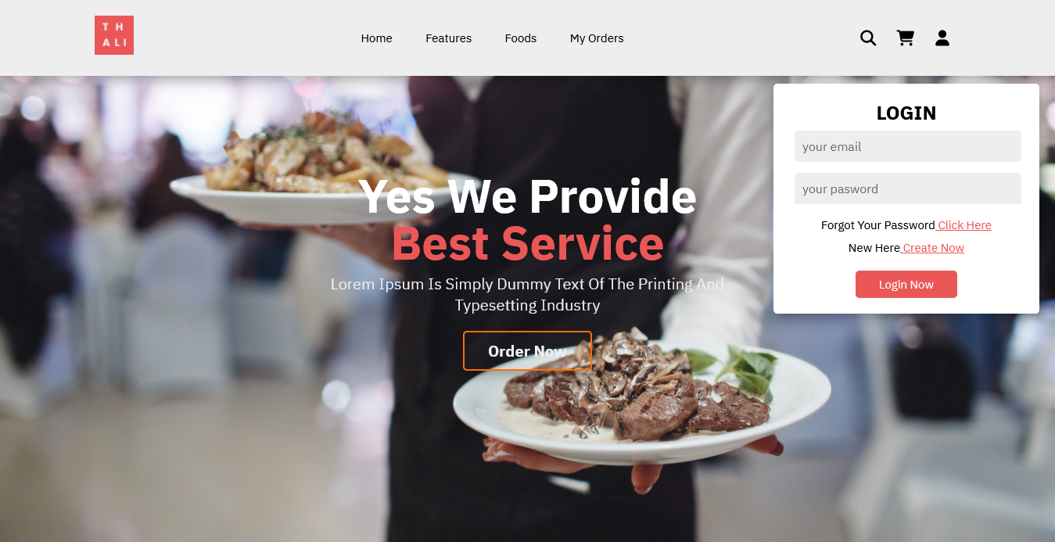

Figure 7. : Login page

Figure 7. 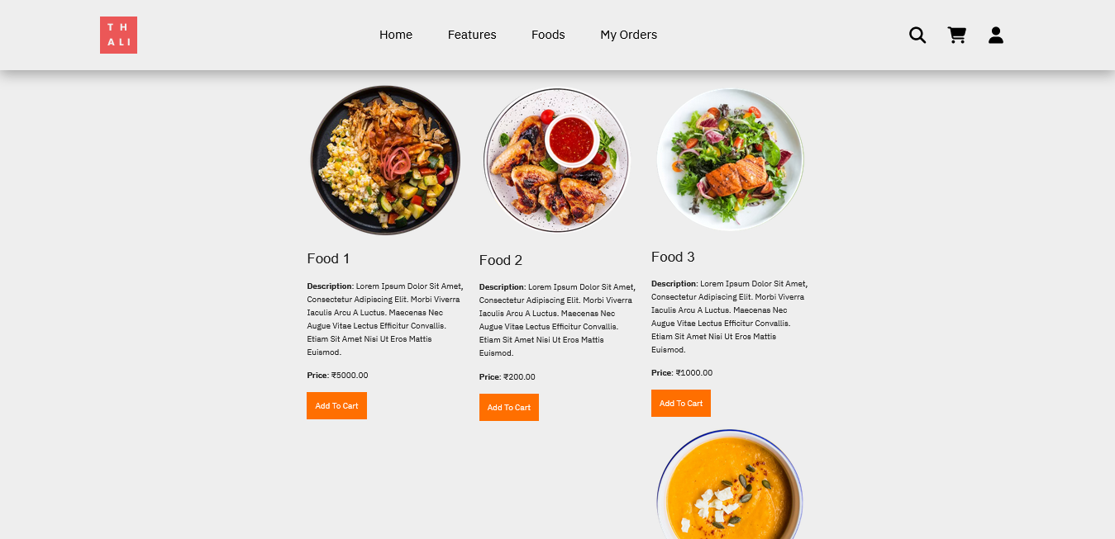: Food Listing

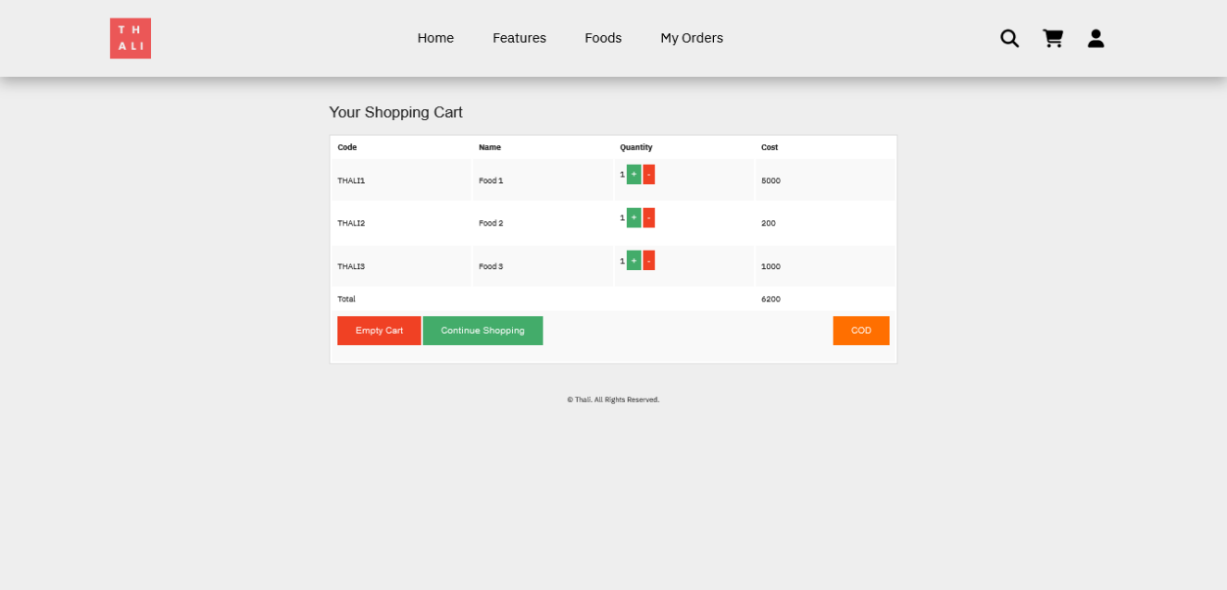

Figure 7. : Cart

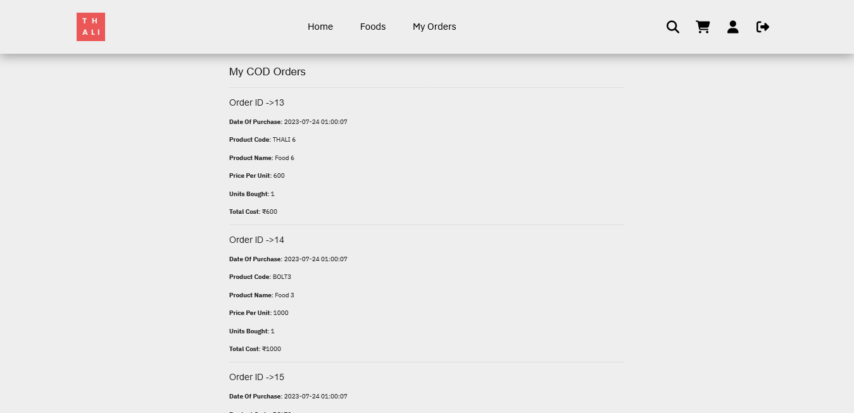Figure 7. : My Orders

Figure 7. 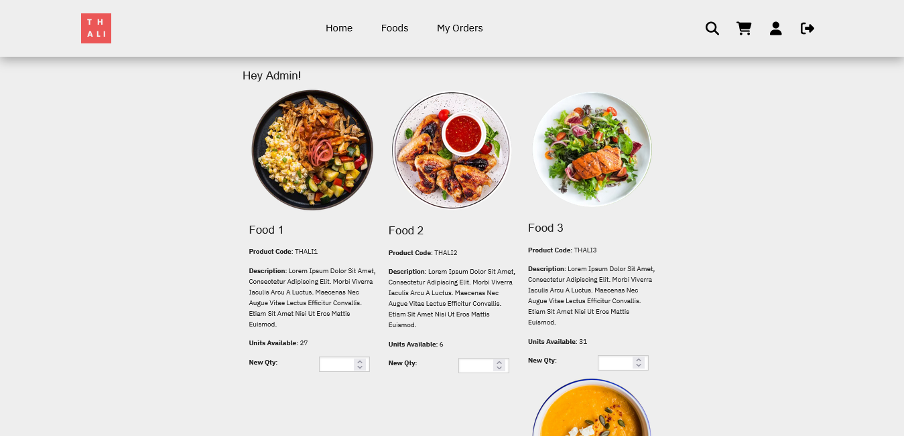: Admin Dashboard

# Source Codes

# Home Page along with login card, Products page, Contact Page.

<?php

session_start();

?>

<!DOCTYPE html>

<html lang="en">

<head>

    <meta charset="utf-8">

    <meta name="viewport" content="width= device-width, initial-scale=1.0">

    <meta http-equiv="X-UA-Compatible" content="ie=edge">

    <title>Home</title>

    <link rel="stylesheet" href="https://cdn.jsdelivr.net/npm/swiper@9/swiper-bundle.min.css" />

    <!-- custom css  -->

    <link rel="stylesheet" href="css/style.css">

    <!-- font awesome cdn link -->

    <link rel="stylesheet" href="https://cdnjs.cloudflare.com/ajax/libs/font-awesome/6.4.0/css/all.min.css">

    <!-- favicon -->

    <link rel="shortcut icon" href="images/thali.png">

</head>

<body>

    <!-- header section -->

    <header class="header">

        <a class="logo" href="index.php">

            <img src="images/thali.png" alt="Doctor appointment Logo" height="50">

        </a>

        <nav class="navbar">

            <a href="#home">Home</a>

            <a href="#features">Features</a>

            <a href="products.php">Foods</a>

            <a href="orders.php">My Orders</a>

        </nav>

        <div class="icons">

            <div class="fas fa-bars" id="menu-bars"></div>

            <div class="fas fa-search" id="search-icon"></div>

            <a href="cart.php"><div class="fas fa-shopping-cart" id="cart-icon"></div></a>

            <div class="fas fa-user" id="login-icon"></div>

        </div>

        <form action="" class="search-form">

            <input type="search" id="search-box" placeholder="search here...">

            <label for="search-box" class="fas fa-search"></label>

        </form>

        <form action="verify.php" method="post" class="login-form">

            <h3>Login</h3>

            <input type="email" placeholder="your email" class="box" name="username">

            <input type="password" placeholder="your pasword" class="box" name="password">

            <p>forgot your password<a href="#"> click Here</a> </p>

            <p>new here<a href="createnew.php"> create now</a> </p>

            <input type="submit" value="login now" class="btn">

        </form>

    </header>

    <!-- header section ends here -->

    <!-- hero section starts  -->

    <section class="home" id="home">

        <div class="content">

            <h1>Yes We Provide <br><span>Best Service</span></h1>

            <p> Lorem Ipsum is simply dummy text of the printing and typesetting industry</p>

            <a href="products.php" class="btn">Order Now</a>

        </div>

    </section>

    <!-- hero sections ends -->

    <!-- Features section starts  -->

    <section class="features" id="features">

        <h1 class="heading"> our <span>features</span> </h1>

        <div class="box-container">

            <div class="box">

                <img src="images/chef.png" alt="">

                <h3>Quality Food</h3>

                <p> dummy text here</p>

                <a href="#" class="btn">read more</a>

            </div>

            <div class="box">

                <img src="images/chef.png" alt="">

                <h3>Free Delivery</h3>

                <p> dummy text here</p>

                <a href="#" class="btn">read more</a>

            </div>

            <div class="box">

                <img src="images/chef.png" alt="">

                <h3>Easy Payments</h3>

                <p> dummy text here</p>

                <a href="#" class="btn">read more</a>

            </div>

        </div>

    </section>

    <!-- Features section ends -->

    <!-- produts section starts -->

    <section class="products" id="foods">

        <h1 class="heading"> our <span>products</span> </h1>

        <div class="swiper product-slider">

            <div class="swiper-wrapper first-child">

                <div class="swiper-slide box">

                    <img src="images/Food 1.jpg" alt="">

                    <h3>Food 1</h3>

                    <div class="price">$50</div>

                    <div class="stars">

                        <i class="fas fa-star"></i>

                        <i class="fas fa-star"></i>

                        <i class="fas fa-star"></i>

                        <i class="fas fa-star"></i>

                        <i class="fas fa-star-half-alt"></i>

                    </div>

                </div>

                <div class="swiper-slide box">

                    <img src="images/Food 2.jpg" alt="">

                    <h3>Food 1</h3>

                    <div class="price">$50</div>

                    <div class="stars">

                        <i class="fas fa-star"></i>

                        <i class="fas fa-star"></i>

                        <i class="fas fa-star"></i>

                        <i class="fas fa-star"></i>

                        <i class="fas fa-star-half-alt"></i>

                    </div>

                </div>

                <div class="swiper-slide box">

                    <img src="images/Food 3.jpg" alt="">

                    <h3>Food 1</h3>

                    <div class="price">$50</div>

                    <div class="stars">

                        <i class="fas fa-star"></i>

                        <i class="fas fa-star"></i>

                        <i class="fas fa-star"></i>

                        <i class="fas fa-star"></i>

                        <i class="fas fa-star-half-alt"></i>

                    </div>

                </div>

                <div class="swiper-slide box">

                    <img src="images/Food 4.jpg" alt="">

                    <h3>Food 1</h3>

                    <div class="price">$50</div>

                    <div class="stars">

                        <i class="fas fa-star"></i>

                        <i class="fas fa-star"></i>

                        <i class="fas fa-star"></i>

                        <i class="fas fa-star"></i>

                        <i class="fas fa-star-half-alt"></i>

                    </div>

                </div>

                <div class="swiper-slide box">

                    <img src="images/Food 4.jpg" alt="">

                    <h3>Food 1</h3>

                    <div class="price">$50</div>

                    <div class="stars">

                        <i class="fas fa-star"></i>

                        <i class="fas fa-star"></i>

                        <i class="fas fa-star"></i>

                        <i class="fas fa-star"></i>

                        <i class="fas fa-star-half-alt"></i>

                    </div>

                </div>

                <div class="swiper-slide box">

                    <img src="images/Food 4.jpg" alt="">

                    <h3>Food 1</h3>

                    <div class="price">$50</div>

                    <div class="stars">

                        <i class="fas fa-star"></i>

                        <i class="fas fa-star"></i>

                        <i class="fas fa-star"></i>

                        <i class="fas fa-star"></i>

                        <i class="fas fa-star-half-alt"></i>

                    </div>

                </div>

                <div class="swiper-slide box">

                    <img src="images/Food 4.jpg" alt="">

                    <h3>Food 1</h3>

                    <div class="price">$50</div>

                    <div class="stars">

                        <i class="fas fa-star"></i>

                        <i class="fas fa-star"></i>

                        <i class="fas fa-star"></i>

                        <i class="fas fa-star"></i>

                        <i class="fas fa-star-half-alt"></i>

                    </div>

                </div>

                <div class="swiper-slide box">

                    <img src="images/Food 4.jpg" alt="">

                    <h3>Food 1</h3>

                    <div class="price">$50</div>

                    <div class="stars">

                        <i class="fas fa-star"></i>

                        <i class="fas fa-star"></i>

                        <i class="fas fa-star"></i>

                        <i class="fas fa-star"></i>

                        <i class="fas fa-star-half-alt"></i>

                    </div>

                </div>

            </div>

            <div class="swiper product-slider">

                <div class="swiper-wrapper">

                    <div class="swiper-slide box">

                        <img src="images/Food 6.jpg" alt="">

                        <h3>Food 1</h3>

                        <div class="price">$50</div>

                        <div class="stars">

                            <i class="fas fa-star"></i>

                            <i class="fas fa-star"></i>

                            <i class="fas fa-star"></i>

                            <i class="fas fa-star"></i>

                            <i class="fas fa-star-half-alt"></i>

                        </div>

                    </div>

                    <div class="swiper-slide box">

                        <img src="images/Food 7.jpg" alt="">

                        <h3>Food 1</h3>

                        <div class="price">$50</div>

                        <div class="stars">

                            <i class="fas fa-star"></i>

                            <i class="fas fa-star"></i>

                            <i class="fas fa-star"></i>

                            <i class="fas fa-star"></i>

                            <i class="fas fa-star-half-alt"></i>

                        </div>

                    </div>

                    <div class="swiper-slide box">

                        <img src="images/Food 8.jpg" alt="">

                        <h3>Food 1</h3>

                        <div class="price">$50</div>

                        <div class="stars">

                            <i class="fas fa-star"></i>

                            <i class="fas fa-star"></i>

                            <i class="fas fa-star"></i>

                            <i class="fas fa-star"></i>

                            <i class="fas fa-star-half-alt"></i>

                        </div>

                    </div>

                    <div class="swiper-slide box">

                        <img src="images/Food 9.jpg" alt="">

                        <h3>Food 1</h3>

                        <div class="price">$50</div>

                        <div class="stars">

                            <i class="fas fa-star"></i>

                            <i class="fas fa-star"></i>

                            <i class="fas fa-star"></i>

                            <i class="fas fa-star"></i>

                            <i class="fas fa-star-half-alt"></i>

                        </div>

                    </div>

                </div>

            </div>

            <div class="swiper-pagination"></div>

        </div>

    </section>

    <!-- product section ends here -->

    <!-- catagory section starts here -->

    <section class="catagories" id="restarunts">

        <h1 class="heading"> Partnered <span>Restaurants</span> </h1>

        <div class="box-container">

            <div class="box">

                <img src="images/restro 2.jpg" alt="">

                <div class="content">

                    <h3>Restaurant 1</h3>

                    <p>dummy text here</p>

                    <div class="stars">

                        <i class="fas fa-star"></i>

                        <i class="fas fa-star"></i>

                        <i class="fas fa-star"></i>

                        <i class="fas fa-star"></i>

                        <i class="fas fa-star-half-alt"></i>

                    </div>

                    <a href="#" class="btn">Order Now</a>

                </div>

            </div>

            <div class="box">

                <img src="images/restro 2.jpg" alt="">

                <div class="content">

                    <h3>Restaurant 2</h3>

                    <p>dummy text here</p>

                    <div class="stars">

                        <i class="fas fa-star"></i>

                        <i class="fas fa-star"></i>

                        <i class="fas fa-star"></i>

                        <i class="fas fa-star"></i>

                        <i class="fas fa-star-half-alt"></i>

                    </div>

                    <a href="#" class="btn">Order Now</a>

                </div>

            </div>

            <div class="box">

                <img src="images/restro 3.jpg" alt="">

                <div class="content">

                    <h3>Restaurant 3</h3>

                    <p>dummy text here</p>

                    <div class="stars">

                        <i class="fas fa-star"></i>

                        <i class="fas fa-star"></i>

                        <i class="fas fa-star"></i>

                        <i class="fas fa-star"></i>

                        <i class="fas fa-star-half-alt"></i>

                    </div>

                    <a href="#" class="btn">Order Now</a>

                </div>

            </div>

            <div class="box">

                <img src="images/restro 3.jpg" alt="">

                <div class="content">

                    <h3>Restaurant 4</h3>

                    <p>dummy text here</p>

                    <div class="stars">

                        <i class="fas fa-star"></i>

                        <i class="fas fa-star"></i>

                        <i class="fas fa-star"></i>

                        <i class="fas fa-star"></i>

                        <i class="fas fa-star-half-alt"></i>

                    </div>

                    <a href="#" class="btn">Order Now</a>

                </div>

            </div>

    </section>

    <!-- catagory section ends here -->

    <!-- Team section starts here -->

    <section class="team" id="team">

        <h1 class="heading"> Brain Behind <span>Thali</span> </h1>

        <div class="box-container">

            <div class="box">

                <img src="images/Mr Sidd.png" alt="">

                <div class="info">

                    <h3>Siddhartha Dwivedi</h3>

                    <p> Graphic and UI/UX Designer </p>

                </div>

                <ul class="social-icons">

                    <a href="https://facebook.com/thesiddartt">

                        <li class="fa-brands fa-facebook-f"></li>

                    </a>

                    <a href="https://instagram.com/the_siddart">

                        <li class="fa-brands fa-instagram"></li>

                    </a>

                    <a href="https://facebook.com/thesiddartt">

                        <li class="fa-brands fa-linkedin-in"></li>

                    </a>

                </ul>

            </div>

            <div class="box">

                <img src="images/new-moon.png" alt="">

                <div class="info">

                    <h3>Seema Bhattarai</h3>

                    <p> dummy text here</p>

                </div>

                <ul class="social-icons">

                    <li class="fa-brands fa-facebook-f"></li>

                    <li class="fa-brands fa-instagram"></li>

                    <li class="fa-brands fa-linkedin-in"></li>

                </ul>

            </div>

        </div>

    </section>

    <!-- Team section ends here -->

    <!-- Customer Review section starts -->

    <section class="review" id="review">

        <h1 class="heading">What Our <span>User's Say</span></h1>

        <div class="swiper review-slider">

            <div class="swiper-wrapper">

                <div class="swiper-slide box">

                    <img src="images/Profile_unblur.png" alt="">

                    <p> Lorem ipsum dolor sit amet consectetur adipisicing elit. Vero, officiis illum reiciendis nobis

                        et error harum blanditiis consequatur excepturi voluptas!</p>

                    <h3> Siddhartha Dwivedi</h3>

                    <div class="stars">

                        <i class="fas fa-star"></i>

                        <i class="fas fa-star"></i>

                        <i class="fas fa-star"></i>

                        <i class="fas fa-star"></i>

                        <i class="fas fa-star-half-alt"></i>

                    </div>

                </div>

                <div class="swiper-slide box">

                    <img src="images/Food 19.jpg" alt="">

                    <p> Lorem ipsum dolor sit amet consectetur adipisicing elit. Vero, officiis illum reiciendis nobis

                        et error harum blanditiis consequatur excepturi voluptas!</p>

                    <h3> Random1</h3>

                    <div class="stars">

                        <i class="fas fa-star"></i>

                        <i class="fas fa-star"></i>

                        <i class="fas fa-star"></i>

                        <i class="fas fa-star"></i>

                        <i class="fas fa-star-half-alt"></i>

                    </div>

                </div>

                <div class="swiper-slide box">

                    <img src="images/Food 19.jpg" alt="">

                    <p> Lorem ipsum dolor sit amet consectetur adipisicing elit. Vero, officiis illum reiciendis nobis

                        et error harum blanditiis consequatur excepturi voluptas!</p>

                    <h3> Random1</h3>

                    <div class="stars">

                        <i class="fas fa-star"></i>

                        <i class="fas fa-star"></i>

                        <i class="fas fa-star"></i>

                        <i class="fas fa-star"></i>

                        <i class="fas fa-star-half-alt"></i>

                    </div>

                </div>

            </div>

        </div>

    </section>

    <!-- Customer review section ends here -->

    <!-- footer section starts here -->

    <?php

    include 'footer.php';

    ?>

    <!-- footer section ends here -->

    <!-- custom js -->

    <script>

        function addToCart(productId) {

            // Send AJAX request to add the product to cart

            var xhr = new XMLHttpRequest();

            xhr.open('POST', 'add_to_cart.php', true);

            xhr.setRequestHeader('Content-type', 'application/x-www-form-urlencoded');

            xhr.onreadystatechange = function() {

                if (xhr.readyState === 4 && xhr.status === 200) {

                    alert(xhr.responseText); // Show success message or handle errors

                }

            };

            xhr.send('productId=' + productId);

        }

    </script>

    <script src="https://cdn.jsdelivr.net/npm/swiper@9/swiper-bundle.min.js"></script>

    <script src="js/script.js"></script>

    <!-- scroll to top buttom -->

    <a href="#" id="back-top"><i class="fa fa-angle-up fa-2x"></i></a>

</body>

</html>

# User Dashboard:

<?php

//if (session_status() !== PHP_SESSION_ACTIVE) {session_start();} for php 5.4 and above

if(session_id() == '' || !isset($_SESSION)){session_start();}

if(!isset($_SESSION["username"])) {

  echo '<h1>Invalid Login! Redirecting...</h1>';

  header("Refresh: 3; url=index.php");

}

if($_SESSION["type"]==="admin") {

  header("location:admin.php");

}

include 'config.php';

?>

<!doctype html>

<html class="no-js" lang="en">

  <head>

    <meta charset="utf-8" />

    <meta name="viewport" content="width=device-width, initial-scale=1.0" />

    <title>My Account || BOLT Sports Shop</title>

    <link rel="stylesheet" href="css/foundation.css" />

    <script src="js/vendor/modernizr.js"></script>

  </head>

  <body>

    <?php

    include 'accountheader.php';

    ?>

    <div class="row" style="margin-top:15rem;">

      <div class="small-12">

        <p><?php echo '<h3>Hi ' .$_SESSION['fname'] .'</h3>'; ?></p>

        <p><h4>Account Details</h4></p>

        <p>Update your details here.</p>

      </div>

    </div>

    <form method="POST" action="update.php" style="margin-top:30px;">

      <div class="row">

        <div class="small-12">

          <div class="row">

            <div class="small-3 columns">

              <label for="right-label" class="right inline">First Name</label>

            </div>

            <div class="small-8 columns end">

              <?php

                $result = $mysqli->query('SELECT * FROM users WHERE id='.$_SESSION['id']);

                if($result === FALSE){

                  die(mysql_error());

                }

                if($result) {

                  $obj = $result->fetch_object();

                  echo '<input type="text" id="right-label" placeholder="'. $obj->fname. '" name="fname">';

                  echo '</div>';

                    echo '</div>';

                  echo '<div class="row">';

                  echo '<div class="small-3 columns">';

                  echo '<label for="right-label" class="right inline">Last Name</label>';

                  echo '</div>';

                  echo '<div class="small-8 columns end">';

                  echo '<input type="text" id="right-label" placeholder="'. $obj->lname. '" name="lname">';

                  echo '</div>';

                  echo '</div>';

                  echo '<div class="row">';

                  echo '<div class="small-3 columns">';

                  echo '<label for="right-label" class="right inline">Address</label>';

                  echo '</div>';

                  echo '<div class="small-8 columns end">';

                  echo '<input type="text" id="right-label" placeholder="'. $obj->address. '" name="address">';

                  echo '</div>';

                  echo '</div>';

                  echo '<div class="row">';

                  echo '<div class="small-3 columns">';

                  echo '<label for="right-label" class="right inline">City</label>';

                  echo '</div>';

                  echo '<div class="small-8 columns end">';

                  echo '<input type="text" id="right-label" placeholder="'. $obj->city. '" name="city">';

                  echo '</div>';

                  echo '</div>';

                  echo '<div class="row">';

                  echo '<div class="small-3 columns">';

                  echo '<label for="right-label" class="right inline">Pin Code</label>';

                  echo '</div>';

                  echo '<div class="small-8 columns end">';

                  echo '<input type="text" id="right-label" placeholder="'. $obj->pin. '" name="pin">';

                  echo '</div>';

                  echo '</div>';

                  echo '<div class="row">';

                  echo '<div class="small-3 columns">';

                  echo '<label for="right-label" class="right inline">Email</label>';

                  echo '</div>';

                  echo '<div class="small-8 columns end">';

                  echo '<input type="email" id="right-label" placeholder="'. $obj->email. '" name="email">';

                  echo '</div>';

                  echo '</div>';

              }

              echo '<div class="row">';

              echo '<div class="small-3 columns">';

              echo '<label for="right-label" class="right inline">Password</label>';

              echo '</div>';

              echo '<div class="small-8 columns end">';

              echo '<input type="password" id="right-label" name="pwd">';

              echo '</div>';

              echo '</div>';

          ?>

          <div class="row">

            <div class="small-4 columns">

            </div>

            <div class="small-8 columns">

              <input type="submit" id="right-label" value="Update" style="background: #0078A0; border: none; color: #fff; font-family: 'Helvetica Neue', sans-serif; font-size: 1em; padding: 10px;">

              <input type="reset" id="right-label" value="Reset" style="background: #0078A0; border: none; color: #fff; font-family: 'Helvetica Neue', sans-serif; font-size: 1em; padding: 10px;">

            </div>

          </div>

        </div>

      </div>

    </form>

    <div class="row" style="margin-top:30px;">

      <div class="small-12">

        <footer>

           <p style="text-align:center; font-size:0.8em;">&copy; BOLT Sports Shop. All Rights Reserved.</p>

        </footer>

      </div>

    </div>

    <script src="js/vendor/jquery.js"></script>

    <script src="js/foundation.min.js"></script>

    <script>

      $(document).foundation();

    </script>

  </body>

</html>

# Admin Dashboard:

<?php

//if (session_status() !== PHP_SESSION_ACTIVE) {session_start();}

if(session_id() == '' || !isset($_SESSION)){session_start();}

if(!isset($_SESSION["username"])) {

  header("location:index.php");

}

if($_SESSION["type"]!="admin") {

  header("location:index.php");

}

include 'config.php';

?>

<!doctype html>

<html class="no-js" lang="en">

  <head>

    <meta charset="utf-8" />

    <meta name="viewport" content="width=device-width, initial-scale=1.0" />

    <title>Admin || Thali</title>

    <link rel="stylesheet" href="css/foundation.css" />

    <script src="js/vendor/modernizr.js"></script>

  </head>

  <body>

    <?php

    include 'accountheader.php';

    ?>

    <div class="row" style="margin-top:10rem;">

      <div class="large-12">

        <h3>Hey Admin!</h3>

        <?php

          $result = $mysqli->query("SELECT * from products order by id asc");

          if($result) {

            while($obj = $result->fetch_object()) {

              echo '<div class="large-4 columns">';

              echo '<img src="images/products/'.$obj->product_img_name.'"/>';

              echo '<p><h3>'.$obj->product_name.'</h3></p>';

              echo '<p><strong>Product Code</strong>: '.$obj->product_code.'</p>';

              echo '<p><strong>Description</strong>: '.$obj->product_desc.'</p>';

              echo '<p><strong>Units Available</strong>: '.$obj->qty.'</p>';

              echo '<div class="large-6 columns" style="padding-left:0;">';

              echo '<form method="post" name="update-quantity" action="admin-update.php">';

              echo '<p><strong>New Qty</strong>:</p>';

              echo '</div>';

              echo '<div class="large-6 columns">';

              echo '<input type="number" name="quantity[]"/>';

              echo '</div>';

              echo '</div>';

            }

          }

        ?>

      </div>

    </div>

    <div class="row" style="margin-top:10px;">

      <div class="small-12">

        <center><p><input style="clear:both; background: #ff6f00;" type="submit" class="button" value="Update"></p></center>

        </form>

        <footer style="margin-top:10px;">

           <p style="text-align:center; font-size:0.8em;">&copy; Thali. All Rights Reserved.</p>

        </footer>

      </div>

    </div>

    <script src="js/vendor/jquery.js"></script>

    <script src="js/foundation.min.js"></script>

    <script>

      $(document).foundation();

    </script>

  </body>

</html>

# Cart.php:

<?php

//if (session_status() !== PHP_SESSION_ACTIVE) {session_start();}

if(session_id() == '' || !isset($_SESSION)){session_start();}

include 'config.php';

?>

<!DOCTYPE html>

<html class="no-js" lang="en">

  <head>

    <meta charset="utf-8" />

    <meta name="viewport" content="width=device-width, initial-scale=1.0" />

    <title>Shopping Cart || Thali</title>

    <link rel="stylesheet" href="css/foundation.css" />

    <script src="js/vendor/modernizr.js"></script>

  </head>

  <body>

    <?php

    include 'header.php';

    ?>

    <div class="row" style="margin-top:100px;">

      <div class="large-12">

        <?php

          echo '<p><h3>Your Shopping Cart</h3></p>';

          if(isset($_SESSION['cart'])) {

            $total = 0;

            echo '<table>';

            echo '<tr>';

            echo '<th>Code</th>';

            echo '<th>Name</th>';

            echo '<th>Quantity</th>';

            echo '<th>Cost</th>';

            echo '</tr>';

            foreach($_SESSION['cart'] as $product_id => $quantity) {

            $result = $mysqli->query("SELECT product_code, product_name, product_desc, qty, price FROM products WHERE id = ".$product_id);

            if($result){

              while($obj = $result->fetch_object()) {

                $cost = $obj->price * $quantity; //work out the line cost

                $total = $total + $cost; //add to the total cost

                echo '<tr>';

                echo '<td>'.$obj->product_code.'</td>';

                echo '<td>'.$obj->product_name.'</td>';

                echo '<td>'.$quantity.'&nbsp;<a class="button [secondary success alert]" style="padding:5px;" href="update-cart.php?action=add&id='.$product_id.'">+</a>&nbsp;<a class="button alert" style="padding:5px;" href="update-cart.php?action=remove&id='.$product_id.'">-</a></td>';

                echo '<td>'.$cost.'</td>';

                echo '</tr>';

              }

            }

          }

          echo '<tr>';

          echo '<td colspan="3" align="right">Total</td>';

          echo '<td>'.$total.'</td>';

          echo '</tr>';

          echo '<tr>';

          echo '<td colspan="4" align="right"><a href="update-cart.php?action=empty" class="button alert">Empty Cart</a>&nbsp;<a href="products.php" class="button [secondary success alert]">Continue Shopping</a>';

          if(isset($_SESSION['username'])) {

            echo '<a href="orders-update.php"><button style="float:right; background: #ff6f00;">COD</button></a>';

          }

          else {

            echo '<a href="login.php"><button style="float:right;">Login</button></a>';

          }

          echo '</td>';

          echo '</tr>';

          echo '</table>';

        }

        else {

          echo "You have no items in your shopping cart.";

        }

          echo '</div>';

          echo '</div>';

          ?>

    <div class="row" style="margin-top:10px;">

      <div class="small-12">

        <footer style="margin-top:10px;">

           <p style="text-align:center; font-size:0.8em;clear:both;">&copy; Thali. All Rights Reserved.</p>

        </footer>

      </div>

    </div>

    <script src="js/vendor/jquery.js"></script>

    <script src="js/foundation.min.js"></script>

    <script>

      $(document).foundation();

    </script>

  </body>

</html>